VISIUAL TOUR OF MAJOR PROJECTS

PICTORIAL
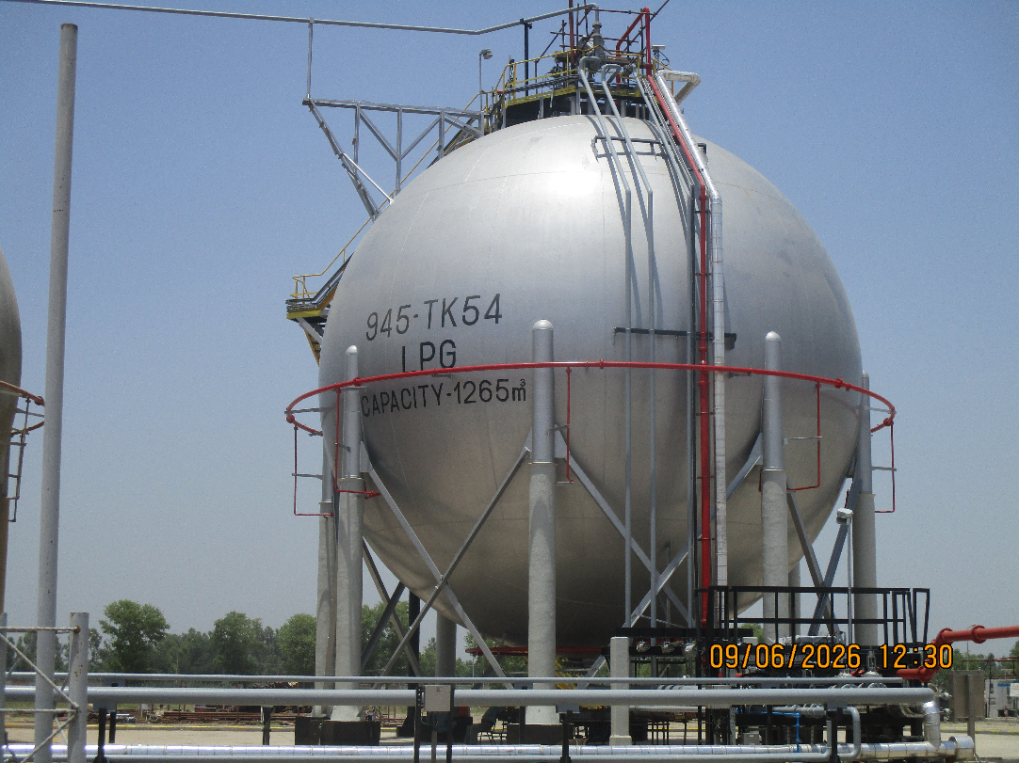
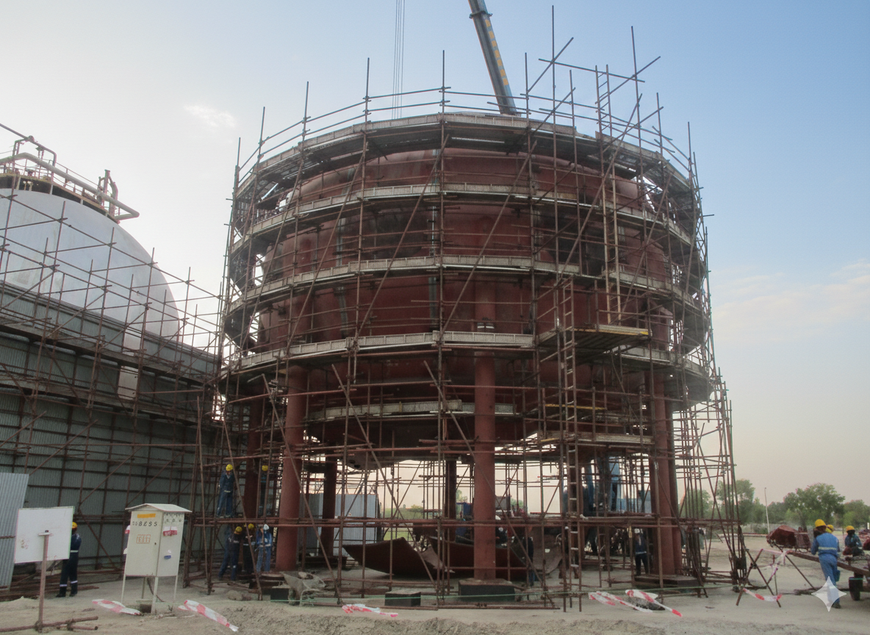
PARCO – New LPG Sphere of Capacity 1530 M3 at PARCO Mahmood kot Refinery - ATL / CIMC Honto (China)
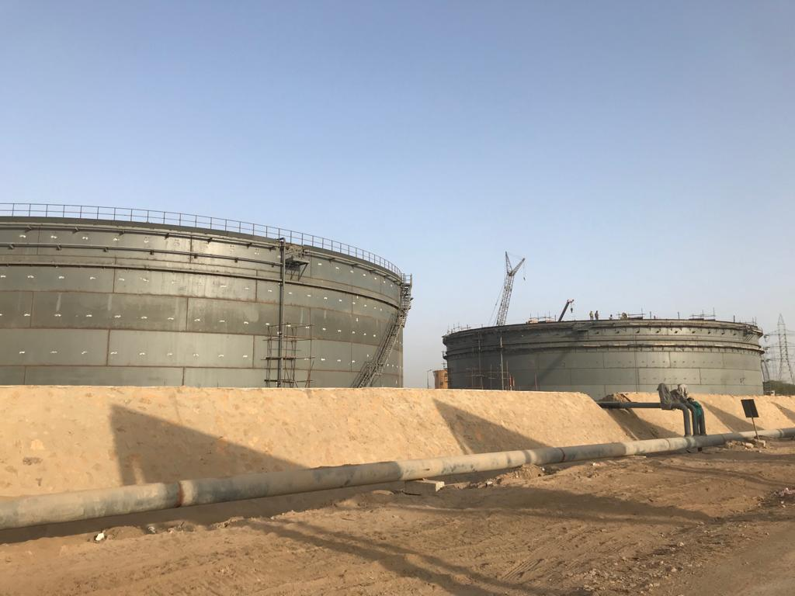 | 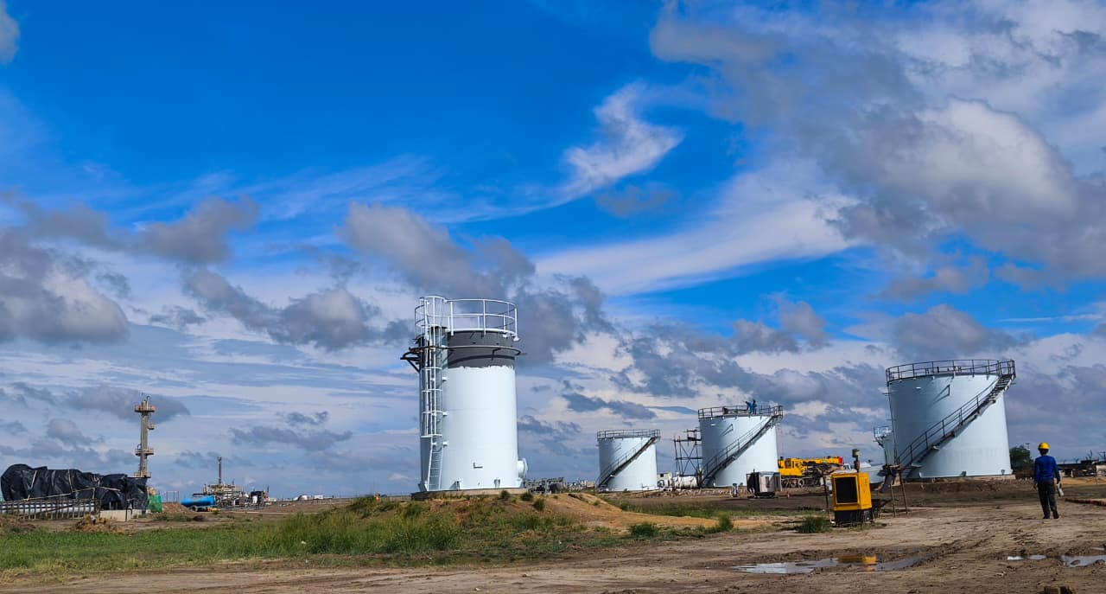
PSO – 02 Nos. 31,000 MT Storage Tanks at Zulfiqarabad Oil Terminal – Port Qasim, Karachi | PPL - Rehabilitation of Field Storage Tanks at Zafir Gas Processing facility Project (09 Nos. Tank)
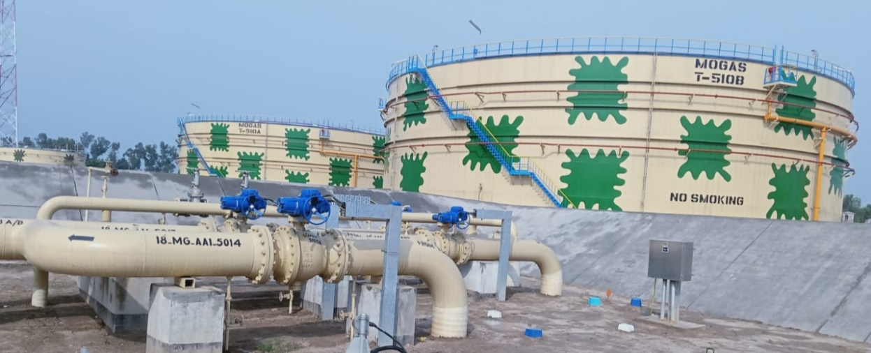
PARCO – Machike, Mehmood Kot, Faisalabad Terminal Station MFM MP, Phase-I
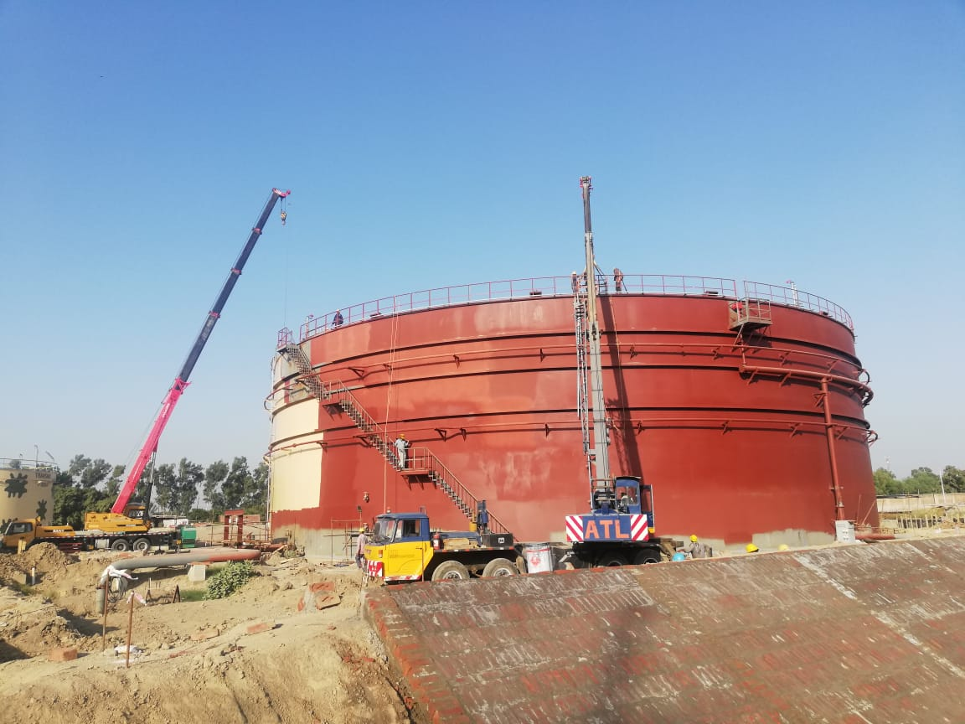 | 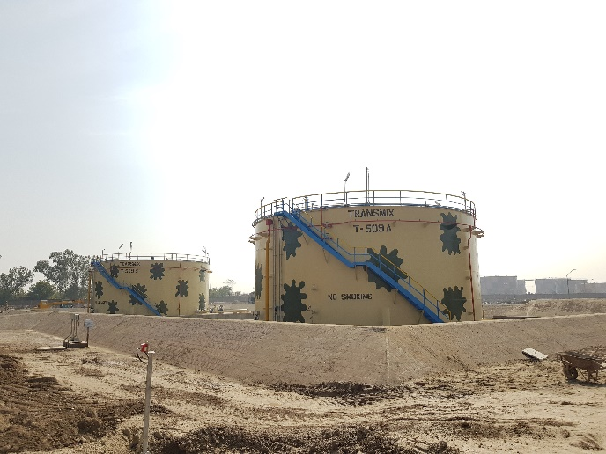
PARCO – Machike, Mehmood Kot, Faisalabad Terminal Station MFM MP, Phase-I
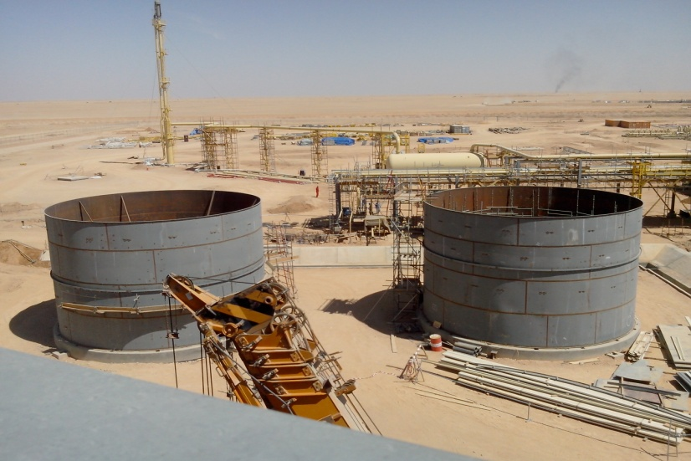 | 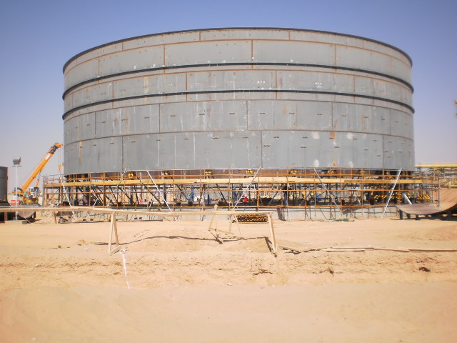
Storage Tanks at Al-Uqlah Central Processing Facility - YEMEN
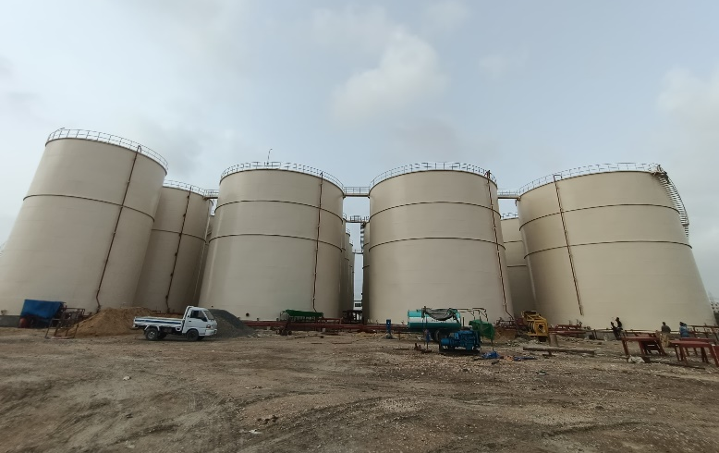 | 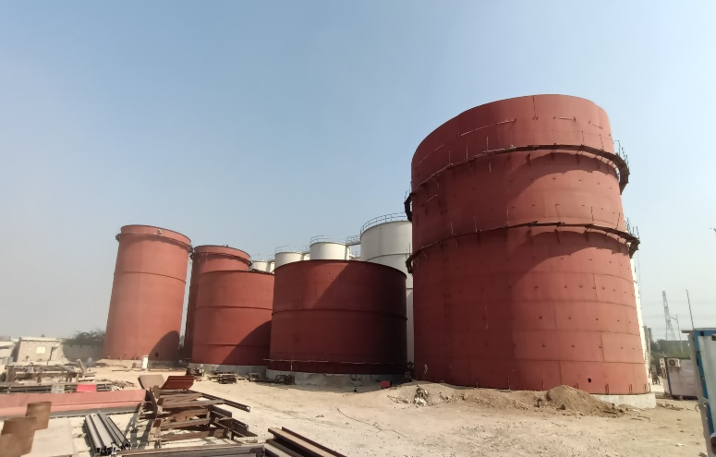
APICAL – Suppy and Construction of 05 Storage Tanks at Port Qasim - Karachi
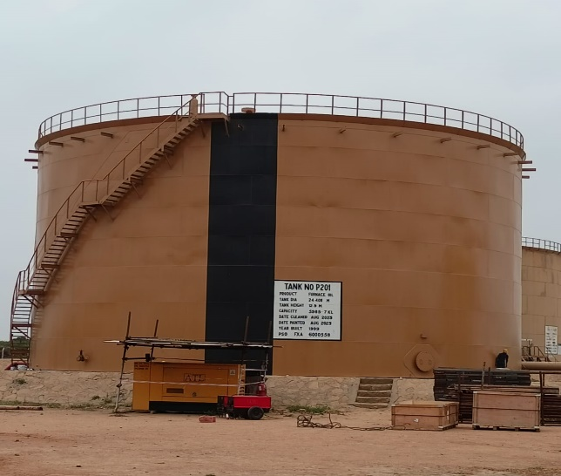 | 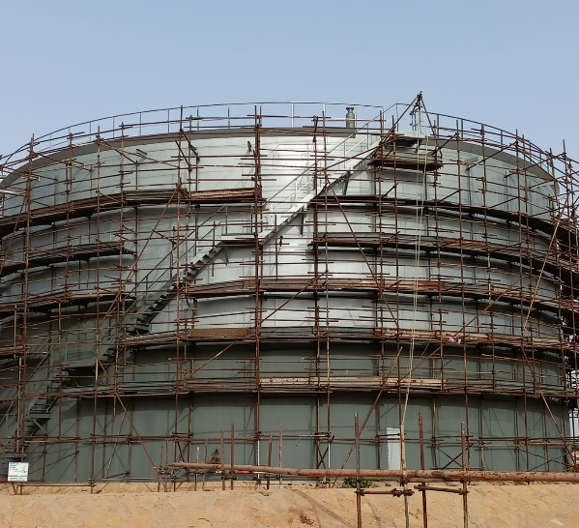
PSO - Rehabilitation of 5500 MT Vertical Storage Tank # 201 AT PMY
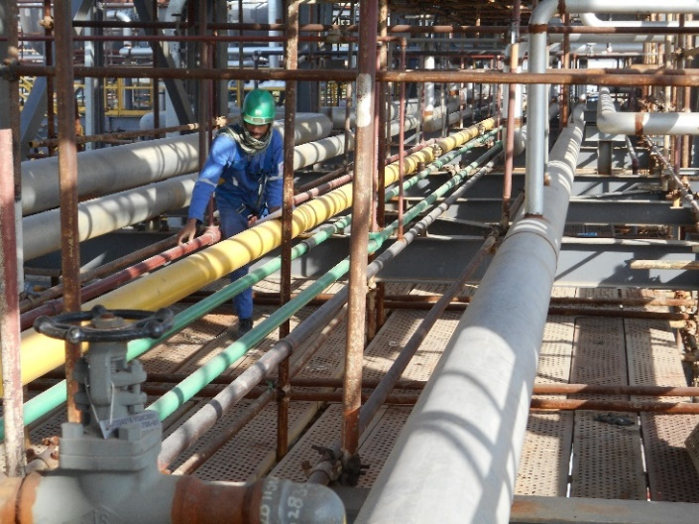 | 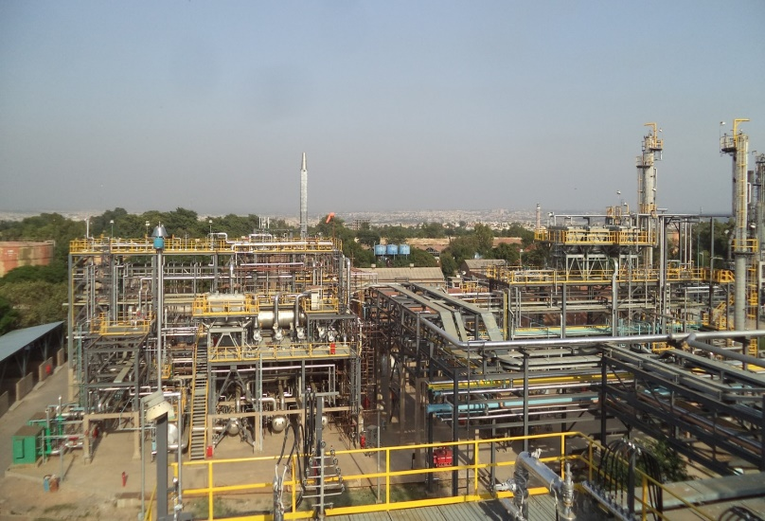
Attock Refinery (Hyundai Engineering - Korea) – Field Piping more than 120,000 dia. inch.
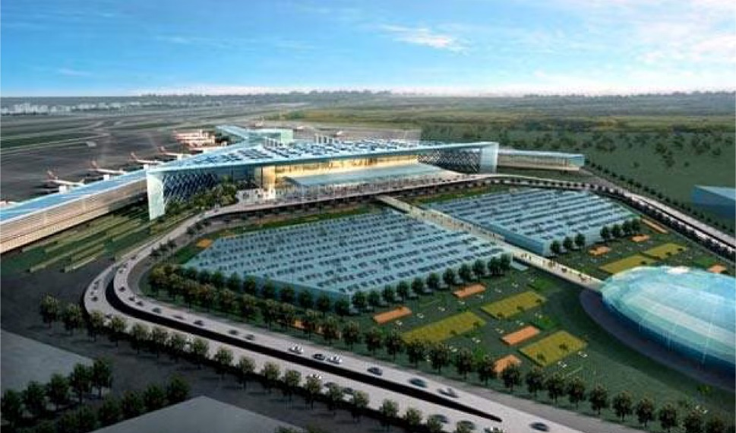
CAA – New Islamabad International Airport
Fuel Hydrent Refuling System
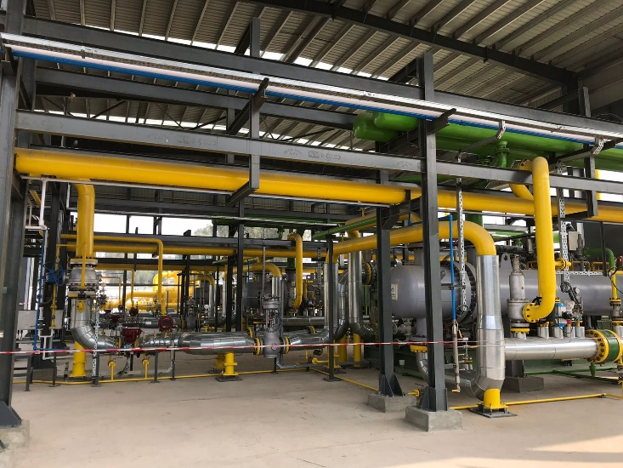 | 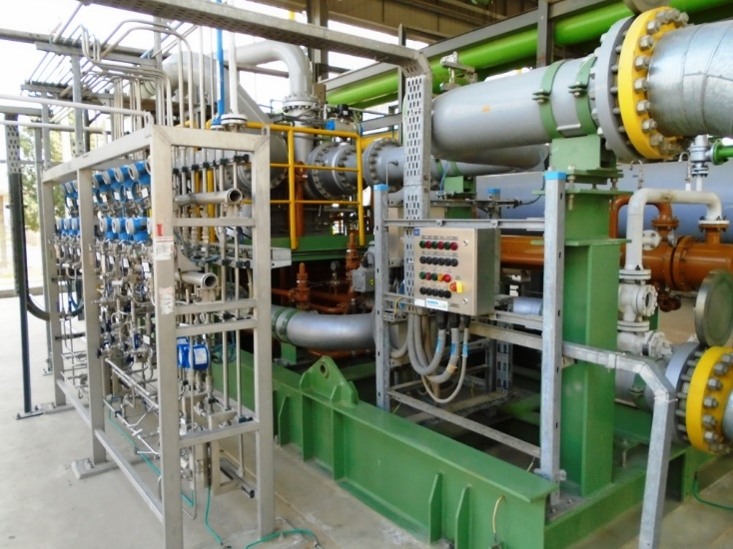
Central Power Generation Company Limited - 747MW Gas Booster Compressor, Guddu
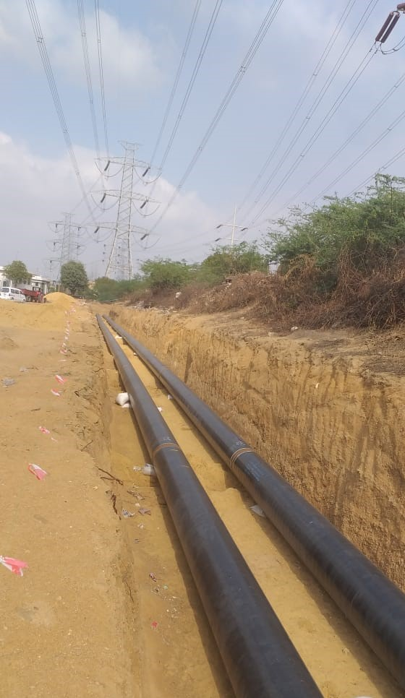 | 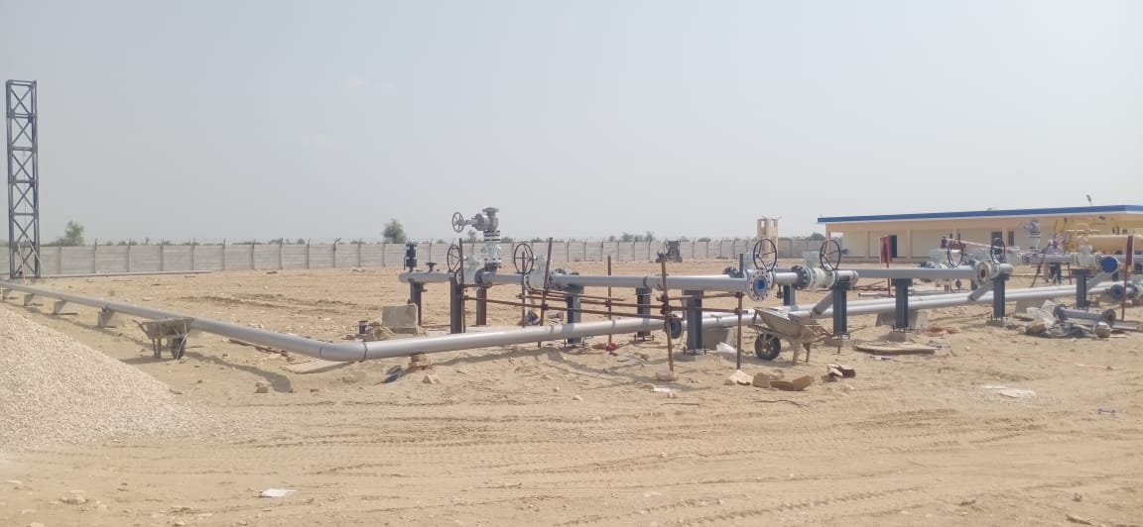
PSO - Development of pipeline link between PSO Booster Station and White Oil Terminal Station PARCO.
24 inch dia pipeline
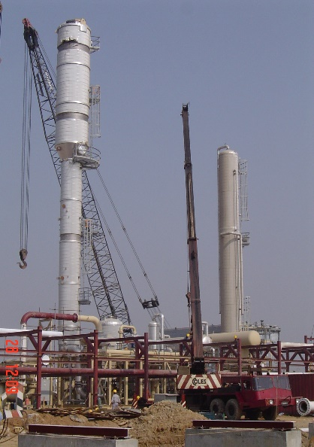 | 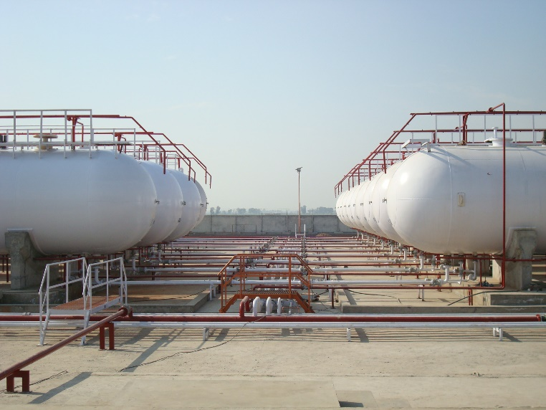
JJVL – Jamshoro Joint Venture Limited / Hanover USA | Lub Gas LPG Terminal, Rana Town Lahore (3600 Ton)
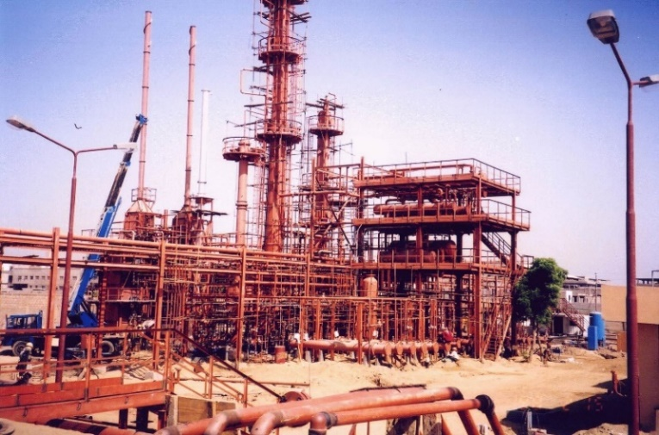 | 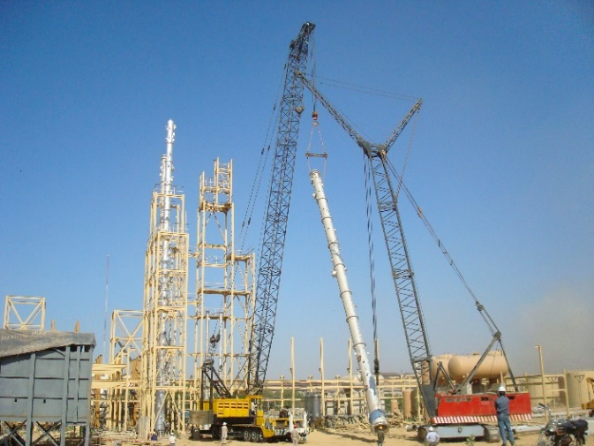
EPRF – I (Korangi, Karachi) | EPRF – II (Near PSM Karachi)
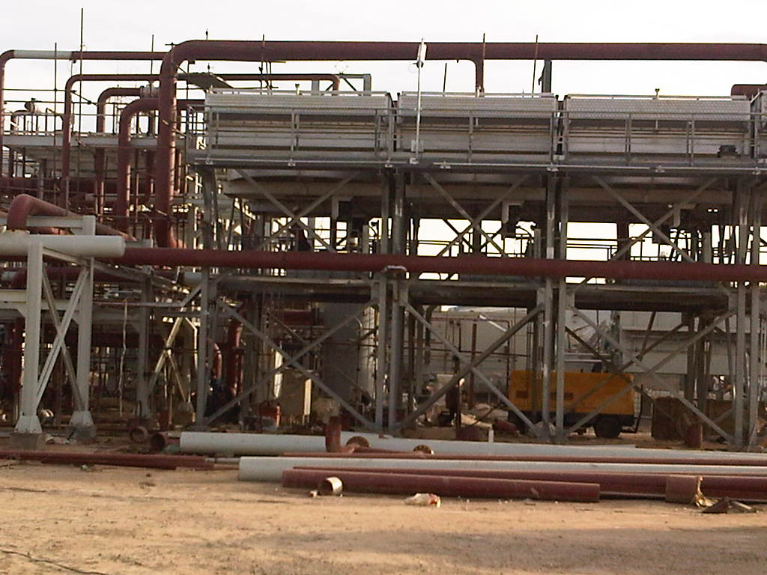 | 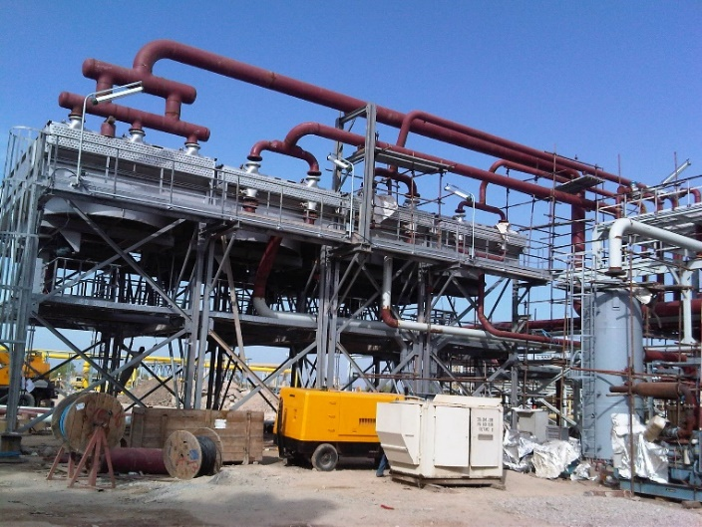
OGDCL – PSM - ATL (Qadirpur) | OGDCL – PSM - ATL (Qadirpur)
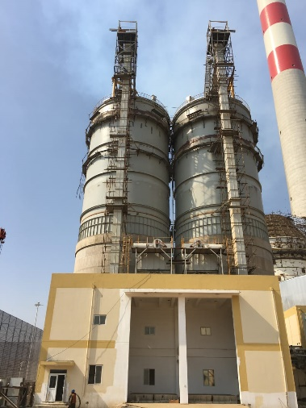 | 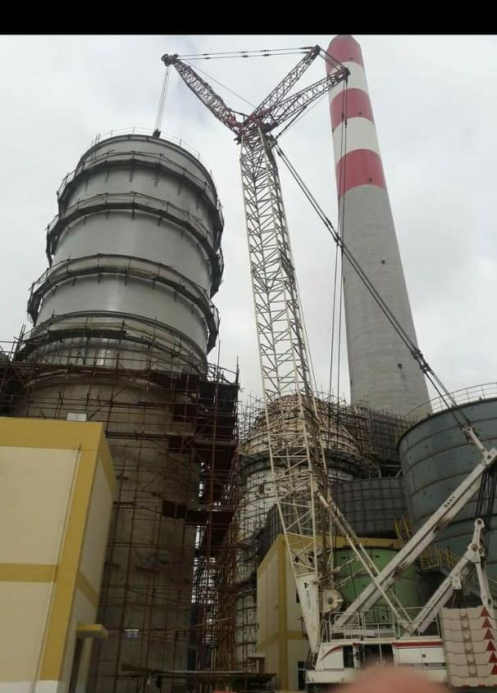
SEPCO-III (China) Port Qasim, Karachi | SEPCO-III (China) Port Qasim, Karachi
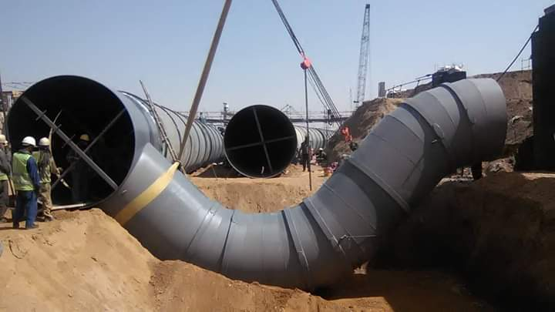 | 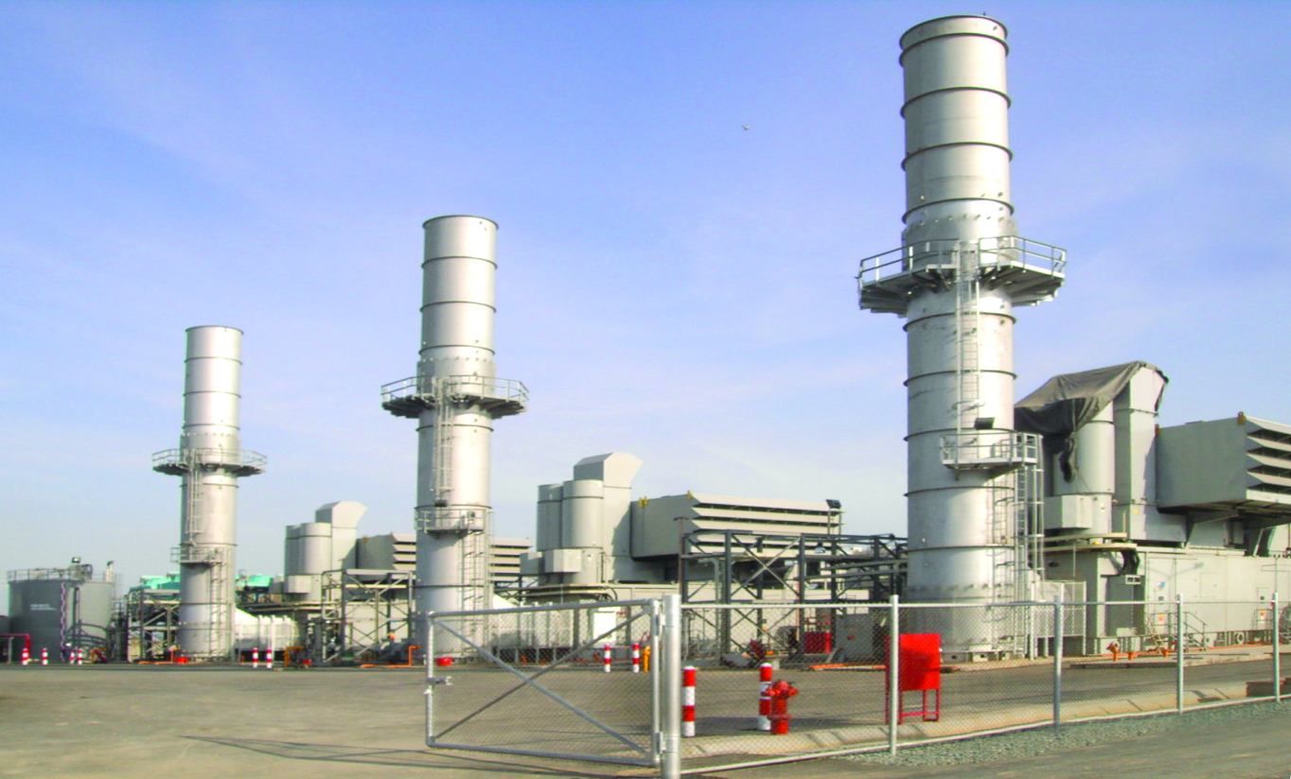
SEPCO-III (China) Port Qasim, Karachi | Bhikki Gas Turbine Power Station
Engro Vopak – Port Qasim
Technopromexport (TPE) – USSR/Russia
3x210 Thermal Power Station - Muzaffargarh

